**System Design Document**

**For**

**Optical (Laser) Communications Low-Cost Payload**

Team Members: Cameron Martinez, Dominic Steiner, Sean Huber, Jarrod Siglin, Matthew Simms, Dylan Koch

|  |  |
| --- | --- |
| Version/Author | Date |
| V1 Dominic Steiner/Cameron Martinez | 10/7/2022 |
|  |  |
|  |  |
|  |  |

TABLE OF contents

1 INTRODUCTION 3

1.1 Purpose and Scope 3

1.2 Project Executive Summary 3

1.2.1 System Overview 3

1.2.2 Design Constraints 3

1.2.3 Future Contingencies 3

1.3 Document Organization 3

1.4 Project References 4

1.5 Glossary 4

2 SYSTEM ARCHITECTURE 4

2.1 System Hardware Architecture 4

2.2 System Software Architecture 4

2.3 Internal Communications Architecture 4

3 HUMAN-MACHINE INTERFACE 4

3.1 Inputs 5

3.2 Outputs 5

4 DETAILED DESIGN 5

4.1 Hardware Detailed Design 6

4.2 Software Detailed Design 6

4.3 Internal Communications Detailed Design 7

5 EXTERNAL INTERFACES 7

5.1 Interface Architecture 7

5.2 Interface Detailed Design 8

6 SYSTEM INTEGRITY CONTROLS 8

System Design Document

# INTRODUCTION

## Purpose and Scope

This System Design Document describes the system requirements, operating environment, system and subsystem architecture, files and database design, input formats, output layouts, human-machine interfaces, detailed design, processing logic, and external interfaces for a Low-Cost Optical Communications System.

## Project Executive Summary

NASA considers optical communications as the emerging technology of choice to enable high-data rate deep space wireless communications. Laser communication systems can achieve data rates beyond 100s of Gbps with payload size, weight, and power typically lower than traditional microwave systems. This project focuses on the design, fabrication, and demonstration of a low-cost optical communications system to be used on small-satellite payloads. It is created on a small scale - tabletop based - and is the concept intended to be utilized in future satellite optical communication.

Software challenges include coding onboard computers for sensor data acquisition and transmission. Hardware challenges include the design and fabrication of a laser diode-based transmitter, a sensor receiver, and a laser pointing mechanism. The system will use commercial off-the-shelf components (COTS) and a few custom-made PCBs to realize this system.

### System Overview

The product is a low-cost optical communication system, consisting of two sub-systems; a transmitter and a receiver. Both systems require a power system. The goal is to have a video feed transmitted via laser and have the receiving device display and store the reception. It is created on a small scale - tabletop based - and is the concept intended to be utilized in future satellite optical communication. All systems will utilize COTS components, leading to lower costs and repeatability.

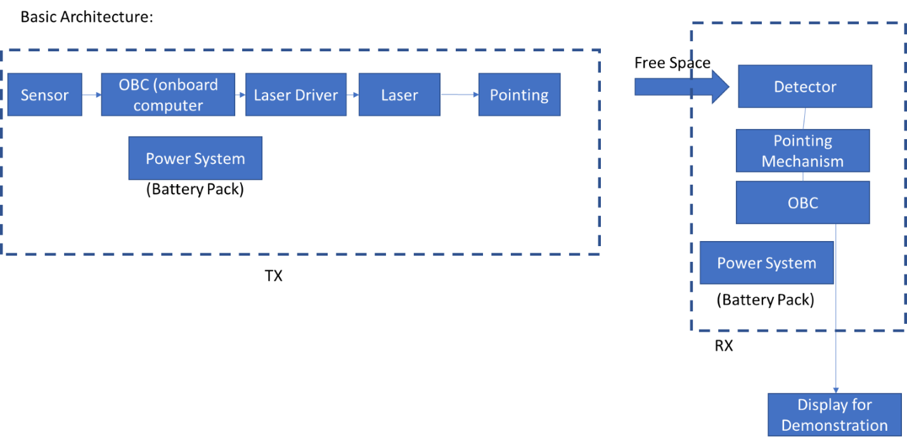

### Design Constraints

The biggest constraint of this system is the scale. It is designed to be a small proof-of- concept for a much larger design. With that in mind, the budget given is low relative to the necessary equipment that will accomplish the task in its entirety. The laser used is low power, thus limiting the information transmission range to less than 3 cm. To compensate for these design constraints, lenses can be used to extend the range of the laser. This creates a more practical system. Another constraint is the budget. The system is designed to be low cost, using COTS components. The target is to keep all component costs below $1500 USD. A small size and budget allow for easier compatibility with satellites, which is the main goal.

### Future Contingencies

A potential problem with long range implementation of a similar system is the spread of the laser versus the size of the receiver. This system has a laser with a high spread and dissipation rate while having a receiver the same width as the original signal. The ratio of the receiver size to transmission width should be large and at a minimum, proportional to the spread rate of whichever laser diode is utilized. The use of lenses to focus the transmission beam is one alternative plan.

## Document Organization

This section describes the organization of the Systems Design Document. The first section is an introduction, then followed by an overall system architecture. The next section is human-machine interface, then a detailed design. The last two sections are external interfaces and system integrity controls.

## Project References

Nothing is currently utilized in our project.

## Glossary

COTS – Commercial-off-the-shelf

PCB – Printed Circuit Board

OBC – Onboard Computer

# SYSTEM ARCHITECTURE

## System Hardware Architecture

Additional design changes may lead to different components, as well as more components. They will be added as they are implemented.

ThorLabs – Optical laser diode

ThorLabs – Optical laser driver

ThorLabs – Optical laser receiver

Raspberry Pi (2x) – Onboard computer for transmitter and receiver

Amplifier Board (Not yet designed) - Will amplify received signal

Oscilloscope and other measurement devices for determining laser functionality

## System Software Architecture

We currently do not have components to begin implementing any software design. Previous software exists from the previous attempt at this project, but its functionality has yet to be tested. Once components are received to allow for this, the usefulness of the previous software will be evaluated.

## Internal Communications Architecture

Components in each subsystem will be wired together to communicate. The transmitter will communicate wirelessly to the receiver via the laser diode. The system is designed to use an OOK serial communication modulation scheme. This will be controlled with the Raspberry Pi and laser driver.

**Note:** The diagrams should map to the FRD context diagrams.

# HUMAN-MACHINE INTERFACE

The only anticipated human-machine interface is the display of the received transmission from the sensor.

## Inputs

The only input to our system as of right now is the voltage being sent from the laser diode. This is controlled by the user. In the future, the input will be the data from the sensor. The sensor, which is a camera, will convert the video feed into a bitstream to be sent to the receiver by using the laser driver and diode.

## Outputs

There is only a power output through the laser diode since it is not currently transmitting any information. In the future, the output will be live video displayed on a screen. The parameters for this display have not been determined yet.

# DETAILED DESIGN

## Hardware Detailed Design



* Sensor: This will be a camera, but no decisions have been made for this component.
* OBC: This is a Raspberry Pi.
* Power System: This will be a custom power system utilizing batteries. Not yet designed.
* Laster Driver: This is the ThorLabs LD1100.
* Laser Diode: The current laser may not be strong enough, so research for a new laser is being done.
* Pointing: This is not a top-level consideration. If the system is complete, consideration will be given to a pointing system.
* Free Space: This is the medium for wireless transmission.
* Detector: This is a receiver for 1550 nm optical wavelength, which is what is being used. It is a APD310 from MenloSystems.
* Display: Most likely a computer screen.

## Software Detailed Design

There is no software incorporated in our present design. Software will be used to modulate and demodulate the signal at the transmitter and receiver, respectively.

## Internal Communications Detailed Design

Our system has no information exchange between the laser diode and the receiver due to there not being any data input, only a power supply. In the design, the sensor will connect to the Raspberry Pi, connected to the laser driver which drives the laser diode. This is all powered by a power system. This transmits to the receiver which connects to the Raspberry Pi for demodulation. Then it is displayed.

# EXTERNAL INTERFACES

## Interface Architecture

The object of this product design will incorporate no interaction with outside systems. As of now the only external interaction is between the laser driver and the fixed power supply in the lab. Since the power system is not yet designed, the system will be connected to external 120V for power. Also, an oscilloscope and signal generators will be used for design and testing.

## Interface Detailed Design

This is an independent system that will not be interacting with outside systems. However, communication, in general, is heavily regulated. Optical communication is a newer field, but with more research done, it's possible these regulations may affect the system.

# SYSTEM INTEGRITY CONTROLS

This is a low hazard and low budget project. The laser output is always kept below 5 mW and it is a fixed system in a relatively secure environment. There are currently no concerns for its safety or the safety of those interacting with the components.